AI Class Tests 1 & 2: Answers from the Lecture Slides
CSE-4132 (Class Test-1) and CSE-4131 (Class Test-2), Artificial Intelligence, Dept. of CSE, RU
Every answer below uses only the content of the uploaded lecture slides (AI_ExamSlide.pdf, 350 slides). Slide numbers are the PDF page numbers and are given after each answer. Where the slides do not contain an answer, this is marked "Answer not found in the provided slides." Where the slides cover only part of a question, the gap is stated.

Class Test-1 (CSE-4132)

Q.1 (a) What is intelligence? (2)
Intelligence is a property of mind that encompasses many related mental abilities, such as the capabilities for:
- Reasoning
- Learning
- Problem solving
- Perception
- Linguistic intelligence
Slide reference: Slides 13-14 ("What is Intelligence?").

Q.1 (b) Explain the following terms (3)
(i) Heuristic knowledge. A special type of knowledge used by humans to solve complex problems. It represents the knowledge of some expert in a field or subject. Examples: good judgments, tricks, rules of thumb.
(ii) Procedural knowledge. Compiled knowledge related to the performance of some task. It gives information about how to achieve something. Example: solving algebraic equations.
(iii) Declarative knowledge. Passive knowledge expressed as statements of facts about the world. It consists of statements that describe a particular object and its attributes, including some behavior in relation to it. Example: personnel data in a database.
Slide reference: Slides 24, 25, 26 ("Five types of knowledge" and "Types of Knowledge").

Q.2 (a) Explain the structure of intelligent agents. (2)
An intelligent agent is anything that perceives its environment through sensors and acts upon that environment through effectors. Its structure can be viewed as:
Agent = Architecture + Agent Program
- Architecture: the machinery that the agent executes on.
- Agent Program: an implementation of the agent function. The agent function is a map from the percept sequence to an action.
the agent types (structures) as:
- Simple Reflex Agents
- Model Based Reflex Agents
- Goal Based Agents
- Utility Based Agents
- Learning Based Agents
Slide reference: Slides 35 (agent definition), 38 (agent function), 42 (Architecture + Agent Program), 43 (agent types).

Q.2 (b) Describe Model Based Reflex Agents with diagram. (2)
Model based reflex agents use a model of the world to choose their actions, and they maintain an internal state.
- Model: knowledge about "how things happen in the world".
- Internal state: a representation of the unobserved aspects of the current state, depending on the percept history.
- Updating the state requires information about how the world evolves and how the agent's actions affect the world.
Diagram (as drawn on the slide):
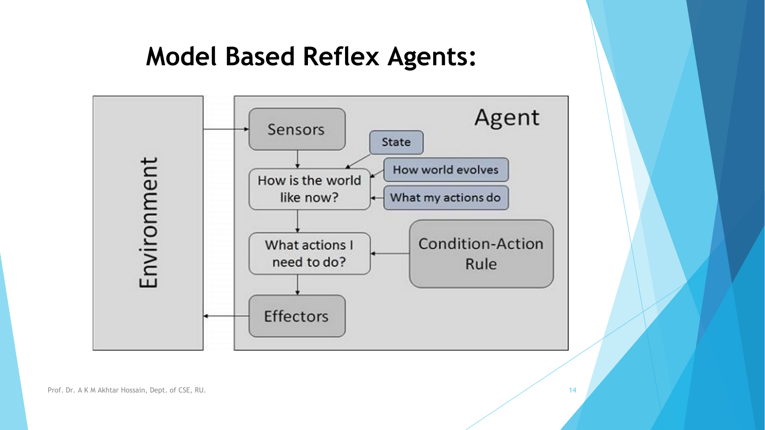
Slide reference: Slides 46-47 ("Model Based Reflex Agents", text and diagram).

Q.2 (c) What is the function of a rational agent? (1)
A rational agent always performs the right action, meaning the action that causes the agent to be most successful for the given percept sequence. An ideal rational agent does the expected actions to maximize its performance measure, on the basis of its percept sequence and its built-in knowledge base.
Rationality depends on:
the performance measure,
the percept sequence so far,
the agent's prior knowledge about the environment, and
the actions the agent can carry out.
Slide reference: Slides 39-40.

Q.3 (a) Define artificial neural network. (1)
An artificial neural network (ANN) is a nothing but a composite functions:
(g_n ∘ f_n ∘ … ∘ g_2 ∘ f_2 ∘ g_1 ∘ f_1)(x)
Each artificial neuron is itself a composite function y = g(f(x)), where f(x) = wx + b is a linear function (weight w, bias b) and g(u) is generally a nonlinear activation function. An ANN is built from an input layer, hidden layers, and an output layer.
Slide reference: Slides 75-78.

Q.3 (b) What are the functions of dendrites and axons of a human neuron cell? (2)
1. Dendrites: (receive),
- Dendrites receive signals from other neurons and carry them toward the cell body.
2. Axons: (send)
- Axons carry electrical signals away from the cell body to other neurons, muscles, or glands.

Answer not found in the provided slides. The slides describe the artificial neuron (input, weight, bias, activation function, output) but contain no description of the biological neuron, dendrites, or axons.

Q.3 (c) Why is the sigmoid activation function used in machine learning? (2)
The slides give only a partial answer:
- Sigmoid is used in the output layer for binary classification (softmax is used for multi-class classification).
- It generates values in the range 0 to 1.
- The sum of sigmoid outputs does not need to be 1 (unlike softmax).
- Activation functions in general are nonlinear functions, chosen according to the range of output values needed.
A fuller explanation (for example, why it is preferred over other activation functions) is not found in the provided slides.
Slide reference: Slides 77, 82, 83.

Class Test-2 (CSE-4131)

Q.1 (a) Explain heuristic function. (2)
A heuristic function is a function applied to a state in a search space to indicate the likelihood of success if that state is selected. Heuristic search is a "rule of thumb" used to guide the search; it is learned from experience and recalled when needed. Heuristic search optimizes a problem by iteratively improving the solution based on a heuristic function or cost measure.
To select the best value, the slides use:
f(n) = g(n) + h(n)
- f(n) = cost of selecting state n
- g(n) = cost of reaching state n from the start state
- h(n) = heuristic value for state n
Procedure: given a search space, a current state and a goal state, generate all successor states, evaluate each with the heuristic function, and select the move with the best heuristic value. The slides illustrate this with the 8-puzzle problem.
Slide reference: Slides 262-264 (definition and formula), 265-267 (8-puzzle example).

Q.1 (b) Explain steepest ascent hill climbing method with example. (3)
Hill climbing is a search where the most promising child is selected for expansion. After the children are generated, they are evaluated with a heuristic function, the most promising path is chosen, and no further reference to the parent or other children is kept.
Steepest ascent hill climbing: generate all successor states of the current state, evaluate them, and move to the one with the highest value available, as long as it is greater than the current value. (In simple hill climbing, by contrast, you move to the first state found with a higher value.) In both, the search can get stuck in a local maximum and never reach the global maximum.
Typical trouble regions in the state space diagram, as defined on the slides: local maximum, plateau (flat local maximum), ridge, and shoulder.
Example (from the slides' hill climbing discussion): you are in an unfamiliar city without a map and want to get downtown, so you simply aim for the tall buildings. The heuristic function is the distance between the current location and the tall buildings, and the desirable states are those where this distance is minimized. Hill climbing can stop whenever a goal state is reached.
Note: the slides do not give a separate worked example specific to steepest ascent; the example above is the one given for hill climbing in general.
Slide reference: Slides 268-270 (hill climbing and example), 272-273 (algorithm), 276-277 (state space regions), 278-279 (types, steepest ascent).

Q.2 Prove by resolution that John can pass the test. (5)
The specific John problem does not appear in the slides, but the slides give the resolution method (proof by refutation), which is applied below.
Step 1: Convert the facts into FOPL
- If someone is intelligent, they can solve problems: ∀x intelligent(x) → solves(x)
- If someone can solve problems, they can pass the test: ∀x solves(x) → passes(x)
- John is intelligent: intelligent(John)
Goal: passes(John)
Step 2: Convert to CNF (using A → B ≡ ¬A ∨ B)
- ¬intelligent(x) ∨ solves(x)
- ¬solves(y) ∨ passes(y)
- intelligent(John)
Step 3: Negate the goal and add it to the knowledge base
- ¬passes(John)
Step 4: Resolution graph
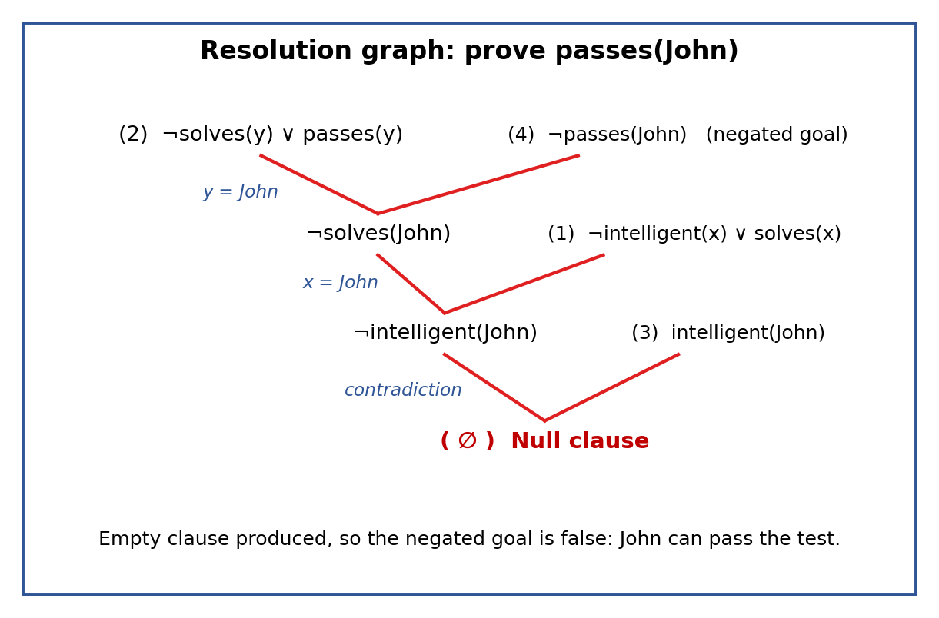
Resolution steps:
- (2) and (4), with y = John, give ¬solves(John).
- ¬solves(John) and (1), with x = John, give ¬intelligent(John).
- ¬intelligent(John) and (3) give the empty clause (Null).
Step 5: Conclusion. The empty clause is produced, so the negated goal leads to a contradiction. Since the knowledge base is consistent, the contradiction comes from the negated goal, hence the original goal is true: John can pass the test.
Slide reference: Slides 200-202 (resolution method and algorithm), 213-214 (negate goal and resolution graph example).

Q.3 (a) Draw the architecture of an Expert System with a suitable diagram. (5)
An expert system is an interactive, reliable computer-based decision-making system that uses both facts and heuristics to solve complex decision-making problems in a specific domain. Its core components are the Knowledge Base and the Inference Engine.
Diagram (as drawn on the slide):
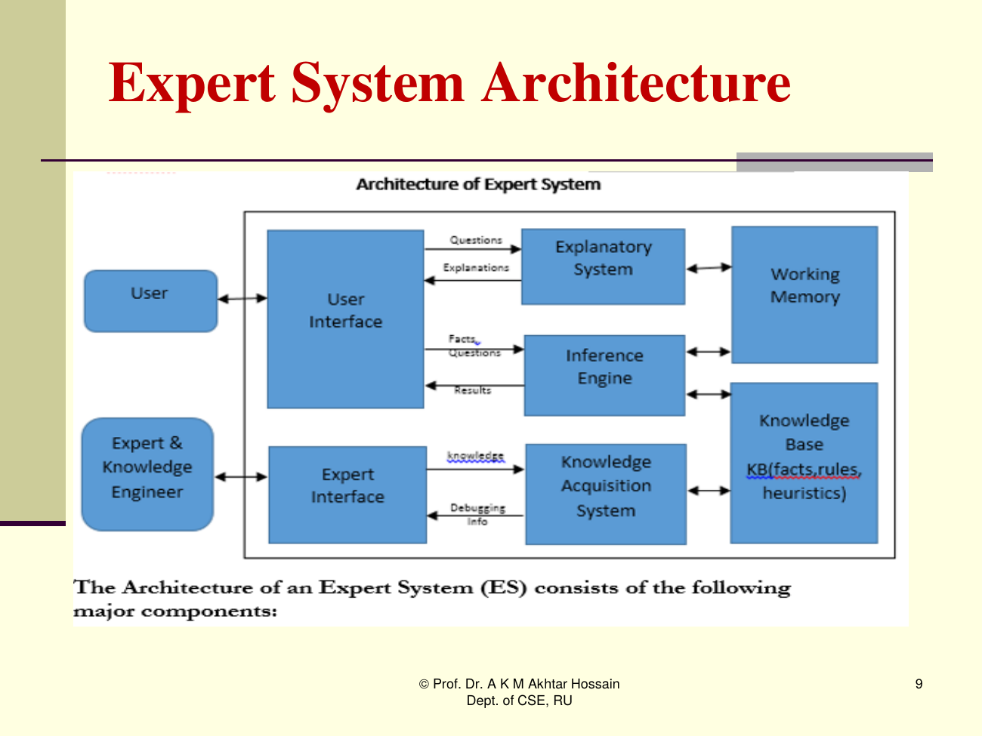
Components:
- Knowledge Base (KB): knowledge about the problem domain as static and dynamic databases. Static knowledge (rules and facts) does not change during execution. Dynamic knowledge (working memory) holds facts for a particular consultation; it starts empty, grows during the consultation, and is deleted at its end.
- Inference Engine: an inference mechanism plus a control strategy. It searches the KB and derives new knowledge using matching and unification, operating with the modus ponens rule. The control strategy decides the order in which rules are applied: forward chaining or backward chaining.
- Knowledge Acquisition module: lets the system acquire knowledge about the domain (from textbooks, reports, research papers, case studies, empirical data, and domain expert experience) and supports insertion, deletion and updating of knowledge.
- Explanation module: the "How" sub-module tells how the system reached a solution; the "Why" sub-module tells why a particular question or solution is offered.
- User interface (dialogue module): lets the user communicate with the system interactively and helps create working knowledge for the problem.
Slide reference: Slides 296-297 (definition, core components), 303 (architecture diagram), 304 (KB), 305 (inference engine), 316 (knowledge acquisition), 317-318 (explanation module), 319 (user interface).

Q.3 (b) Explain non-monotonic TMS with example. (3)
A Truth Maintenance System (TMS) works with an inference engine (IE) and knowledge base (KB) to solve problems in large search spaces, and it maintains the beliefs of a general problem-solving system. A TMS can implement monotonic or non-monotonic systems.
Non-monotonic TMS:
- New information can be added that causes the deletion or alteration of existing knowledge.
- It allows retraction of truths already in the system whenever contradictions arise, so the number of axioms can both increase and decrease, and the KB is updated as it changes.
- A logic is non-monotonic if some conclusions can be invalidated by adding more knowledge.
- It is useful for representing defaults: a default is a rule that can be used unless it is overridden by an exception.
- By contrast, in a monotonic system (for example predicate logic), once a fact is stored it cannot change and the set of axioms only grows.
Example (from the slides):
- Facts: Birds can fly. Penguins can't fly. Alex is a bird.
- Conclusion: Alex can fly.
- If we then learn that Alex is a penguin, this conclusion is invalidated and must be retracted.
Second slide example: Penguin cannot fly; birds have wings; birds can fly; a penguin is a bird. The conclusion "Penguin can fly" (from "penguin is a bird") is overridden by the exception "penguin cannot fly".
Slide reference: Slides 223-224 (TMS definition, monotonic vs non-monotonic), 229 (non-monotonic TMS), 230-231 (examples).

Summary of slide coverage
Question | Marks | Coverage in slides
CT1 Q1(a) Intelligence | 2 | Full (13-14)
CT1 Q1(b) Heuristic, procedural, declarative knowledge | 3 | Full (24-26)
CT1 Q2(a) Structure of intelligent agents | 2 | Full (42-43)
CT1 Q2(b) Model based reflex agent with diagram | 2 | Full (46-47)
CT1 Q2(c) Function of a rational agent | 1 | Full (39-40)
CT1 Q3(a) Define ANN | 1 | Full (75-78)
CT1 Q3(b) Dendrites and axons | 2 | Answer not found in the provided slides
CT1 Q3(c) Why sigmoid is used | 2 | Partial (83); fuller reasoning not in slides
CT2 Q1(a) Heuristic function | 2 | Full (262-267)
CT2 Q1(b) Steepest ascent hill climbing with example | 3 | Definition full (279); example is the general hill climbing one (269-270)
CT2 Q2 Resolution (John) | 5 | Method from slides (200-202); problem solved by applying it
CT2 Q3(a) Expert system architecture | 5 | Full (303-320)
CT2 Q3(b) Non-monotonic TMS with example | 3 | Full (223-231)

